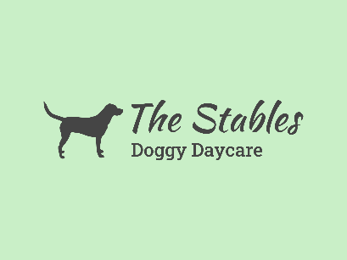

Terms and Conditions (updated)
Opening times are 7.30 am to 6pm, Monday to Friday, priced at £25 a day.
Dogs cannot be dropped off before 7.30 and must be collected by 6pm, a fee of £10 per 15 minutes will be added to the bill if the dog is collected late. I cannot stress how important it is that your dogs are collected by 6pm. Owners who repeatedly collect late, may be asked to leave Daycare for good.
All owners are required to fill in a booking form, consent form and vaccination log. It is the owner’s responsibility to update me with any changes to this, ie a change of address etc.
Invoices will be sent out weekly, usually Friday evening and payment is required as soon as possible. Owners are asked to put the invoice number as a reference, to allow me to track payments. Subsequent weeks will not be bookable if payment isn’t up to date.
Could owners please give as much notice as possible for holidays etc.
From November 2024 onwards there is a one week cancellation policy. If a session is cancelled for any reason within that week, full payment is still required.
We are closed all Bank holidays.
We will be closed over the Christmas period, Monday 23rd December - Friday 3rd January. We will be back open as usual Monday 6th January.
Closures will be communicated with as much notice as possible.
A free meet and greet introductory session is available for all new clients. This needs to be booked in advance. And is arranged outside of the daycare hours.
Doggy daycare is not suitable for all dogs. Dogs attending should be house trained, socialised, good with humans and have basic manners. We will not accept dogs who continuously bark.
Dogs are required to be fully vaccinated; proof is needed for this. Kennel Cough is optional, but recommended. Owners are also expected to stay uptodate on any flea and worming treatment.
Dogs must be microchipped, with their current address registered.
We cannot accept female dogs in season for three weeks.
We cannot accept any intact males over the age of one years old. Current male pups will be given a discretionary period in which to organise this.
We cannot accept any dogs with sickness and diarrhoea. Any dogs that become sick whilst in daycare will be separated and their owner contacted for prompt collection.
The safety of the dogs is of the upmost importance. All dog interaction is monitored. In the unlikely event that your dog is involved in an accident, The Stables doggy daycare does not accept any responsibility for accidental death, injury or illness whilst your dog in their care. Owners are strongly advised to have insurance for all eventualities.
Any excessive damages made to the property must be paid for.
We reserve the right to refuse or terminate the contract of any dog or owner who displays aggression, destructive or unreasonable behaviour with no notice.

Terms and condition s will be updated or changed when required. Any updates will be emailed to all current owners.

